MINISTRY OF EDUCATION AND SCIENCE OF UKRAINE

NATIONAL TECHNICAL UNIVERSITY

“KHARKOV POLYTECHNICAL INSTITUTE”

LABORATORY WORK № 4

# “Using Basic Java”

Created by student of 1.КН.201.8г

Chukwu Irele Omike

Checked by

KHARKIV 2019

### 1.1 Individual Assignment

You should create console Java application that calculates values of a function on a given range. The necessary source data (interval boundaries and step of argument increasing) should be read from keyboard.

The creation of the program should be preceded by an investigation of the behavior of the function at different intervals.

You should explore your function's behaviour first. Program should contain such parts:

* reading data from command line
* main loop, in which you set a new value of argument and show this value with calculated value of function, and then increase value of argument.

Program should be split into two functions.

Particular function is given in the individual task according to your own index in the group students list (index of variant).

Table 1.1 - Individual Assignments

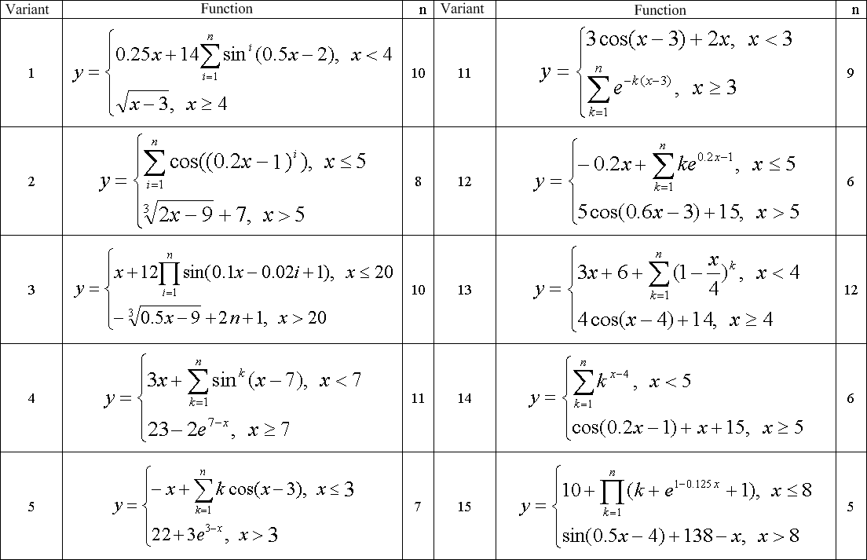

### 1.2 Powers of 8

Read integer value of n (from 1 to 10) and display powers of 8 from 1 to n. Implement two approaches: using arithmetic and bitwise operations.

### 1.4 Factorials

Implement a program that reads integer value of n and calculates factorial of n:

n! = 1 * 2 * ... * n.

Implement a program in two ways: through the cycle and using a recursive function.

Task 1:

The code :

**package** functioncalculation;

**import** java.util.*;

**public** **class** main

{

**public** **static** **void** main(String[] args)

{

Scanner scanner = **new** Scanner(System.***in***);

**double** valueX = 0;

**double** valueN = 0;

System.***out***.print("Enter X: ");

valueX = scanner.nextDouble();

System.***out***.print("Enter N: ");

valueN = scanner.nextDouble();

*calculate*(valueX, valueN);

}

**private** **static** **void** calculate(**double** x, **double** n)

{

**if** (x <= 3)

{

**double** summary = -x;

**for** (**int** i = 1; i < n; i++)

{

summary += (i * Math.*cos*(x - 3));

System.***out***.println("Calculation step: " + summary);

}

System.***out***.println("Result: " + summary);

}

**else**

{

**double** summary = (22 + Math.*pow*(Math.*exp*(3), 3 - x));

System.***out***.println("Result: " + summary);

}

}

}

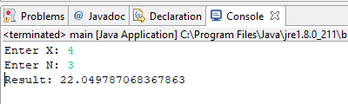

Task2 :

**package** powerof8;

**import** java.util.*;

**public** **class** Main {

**public** **static** **void** main(String[] args)

{

**final** **int** power = 8;

Scanner scanner = **new** Scanner(System.***in***);

System.***out***.print("Enter number: ");

**int** number = scanner.nextInt();

**int** result = number;

**if** (number >= 1 && number <= 10)

{

**for** (**int** i = 1; i < power; i++)

{

result *= number;

}

System.***out***.println(result);

}

}

Execution :

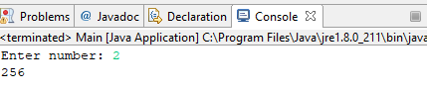

Task3 :

The code:

**package** factorials;

**import** java.util.*;

**public** **class** Main {

**public** **static** **void** main(String[] args)

{

Scanner scanner = **new** Scanner(System.***in***);

System.***out***.print("Enter number: ");

**int** number = scanner.nextInt();

**int** factorial = 1;

**for** (**int** i = 2; i <= number; i++)

{

factorial *= i;

}

System.***out***.println("Factorial: " + factorial);

}

}

Execution:

